DESIGN AND IMPLEMENTATION OF A CAR SAFETY SYSTEM WITH OBSTACLE DETECTION AND FREE PARKING SPACE ALLOCATION.

BY

ANONGU MICHAEL TERFA
21/57436/UE

&

ABA SAMUEL TERLUMUN
21/57453/UE

DEPARTMENT OF ELECTRICAL AND ELECTRONICS ENGINEERING,
JOSEPH SARWUAN TARKA UNIVERSITY, MAKURDI.

June, 2026
DESIGN AND IMPLEMENTATION OF A CAR SAFETY SYSTEM WITH OBSTACLE DETECTION AND FREE PARKING SPACE ALLOCATION.

BY

ANONGU MICHAEL TERFA
21/57436/UE

&
ABA SAMUEL TERLUMUN
21/57453/UE

Project Submitted to the Department of Electrical and Electronics Engineering,
Joseph Sarwuan Tarka University, Makurdi, in Partial Fulfilment of the Award of Bachelor
of Engineering in Electrical and Electronics Engineering.

June, 2026

DECLARATION
We declare that the work described in this project is original and has not been previously submitted to any university or similar institution for the award of any degree or certification.

Name of Candidates: ANONGU MICHAEL TERFA
Registration Number: 21/57436/UE
Signature: ………………………………………………………………………….
Date……………………………………………………………………………...

Name of Candidates: ABA SAMUEL TERLUMUN
Registration Number: 21/57453/UE
Signature: ………………………………………………………………………….
Date……………………………………………………………………………...

CERTIFICATION
We, the undersigned, hereby certify that this research project presented by ANONGU MICHAEL TERFA (21/57436/UE) and ABA SAMUEL TERLUMUN (21/57453/UE), is accepted as fulfilling part of the requirements for the award of the degree of Bachelor of Engineering in Electrical and Electronics Engineering.

Engr. Manji Yilwatda ………………………………….
Supervisor Signature/ Date

Engr. Madukwe C. A. …………………………………
Project Coordinator Signature/ Date

Engr. Dr E. T. Iorkayse …………………………………
Head of Department Signature/ Date

DEDICATION
This work is dedicated to God Almighty who sustained our lives during our study.

ACKNOWLEDGEMENT
First and foremost, we sincerely appreciate God Almighty for His faithfulness, mercy, and abundant grace throughout the course of this project. His divine guidance, protection, and strength sustained us through every challenge and enabled the successful completion of this work.
We are especially grateful to our supervisor, Engr. Manji Yilwatda, whose invaluable guidance, insightful recommendations, and continuous support greatly contributed to the success of this project. His willingness to share his knowledge, provide direction, and offer constructive criticism helped shape both the quality and outcome of this research.
We also extend our gratitude to the Department of Electrical and Electronics Engineering, Joseph Sarwuan Tarka University, for creating an enabling environment for learning and research. The support, facilities, and academic resources provided by the department were instrumental to the completion of this study.
Our appreciation goes to all our lecturers and members of staff whose dedication to teaching and mentorship laid the foundation upon which this work was built. The knowledge and skills acquired through their instruction have been invaluable.
We are equally thankful to our friends and colleagues for their encouragement, cooperation, and meaningful contributions during the course of this project. Their ideas, feedback, and support proved beneficial in many aspects of this work.
Finally, we express our deepest gratitude to our families for their unwavering support, understanding, sacrifices, and constant encouragement. Their confidence in us and their continued prayers provided the motivation and strength needed to see this project through to completion.

Table of Contents
DECLARATION i
CERTIFICATION ii
DEDICATION iii
ACKNOWLEDGEMENT iv
1 INTRODUCTION 1
1.1 Background of the Study 1
1.2 Statement of the Problem 2
1.3 Aim 3
1.4 Objectives 3
1.5 Significance of the Study 3
1.6 Scope of the Study 5
2 LITERATURE REVIEW 6
2.1 Theoretical Foundation of the Proposed System 6
2.1.1 Embedded system concept 6
2.1.2 Time-of-flight distance measurement principle 6
2.2 Ultrasonic Sensing Technology 6
2.2.1 Overview of ultrasonic sensors 6
2.2.2 Construction of the HC-SR04 ultrasonic sensor 7
2.2.3 Working principle of HC-SR04 7
2.3 Microcontroller Technology 8
2.3.1 Arduino Nano development board 8
2.3.2 Technical specifications of Arduino Nano 8
2.3.3 Arduino Nano pin description 9
2.3.4 Functions of the Arduino Nano in the proposed system 10
2.3.5 Liquid Crystal Display (LCD) 10
2.3.6 I²C LCD interface 11
2.3.7 Electronic buzzer technology 11
2.4 Software Development Tools 12
2.4.1 Arduino Integrated Development Environment (IDE) 12
2.4.2 Proteus design suite 13
2.5 Conceptual Framework 13
2.6 Development of Block Diagram 14
2.6.1 Unit 1 Obstacle Avoidance System 14
2.6.2 Unit 2 Parking Space Allocation System 15
2.7 Review of Related Empirical Studies 16
2.8 Summary of Literature Review 17
3 CIRCUIT ANALYSIS AND DESIGN 18
3.1 Introduction 18
3.2 Arduino Nano Microcontroller – Central Processing Unit 18
3.2.1 Pin Assignment and Rationale – Unit 1 18
3.2.2 Pin Assignment and Rationale — Unit 2 19
3.3 HC-SR04 Ultrasonic Sensor Interface and Distance Calculation 20
3.3.1 Trigger Pulse Timing 20
3.3.2 Distance Calculation 20
3.3.3 Sensor Polling Sequence – Unit 1 21
3.4 Obstacle Detection Logic and Distance Thresholds – Unit 1 21
3.5 Parking Slot Occupancy Logic — Unit 2 22
3.6 Buzzer Driver Circuit — Unit 1 22
3.6.1 Series Resistor Calculation 22
3.7 LED Indicator Circuits – Both Units 23
3.7.1 Series Resistor Calculation 23
3.8 16×2 I²C LCD Module Interface – Both Units 23
3.8.1 I²C Pull-up Resistor Verification 24
3.9 Power Supply Analysis – Both Units 24
3.9.1 Unit 1 Current Demand 24
3.9.2 Unit 2 Current Demand 25
3.9.3 Regulator Heat Dissipation 25
3.10 Circuit Diagrams 25
3.11 System Flowcharts 27
3.12 Programming 29
3.12.1 Unit 1 Firmware Modules 29
3.12.2 Unit 2 Firmware Modules 29
3.13 Summary of Circuit Design 29
REFERENCES 31

TABLE OF TABLES
Table 2.1 Technical specifications of HC-SR04 7
Table 2.2 Arduino Nano Pin Allocation Unit 1 (Obstacle Avoidance System) 9
Table 2.3 Arduino Nano Pin Allocation Unit 2 (Parking Space Allocation System) 10
Table 3.1 Arduino Nano Pin Allocation — Unit 1 (Obstacle Avoidance) 19
Table 3.2 Arduino Nano Pin Allocation — Unit 2 (Parking Space Allocation) 20
Table 3.3 Obstacle Detection Zones and System Responses — Unit 1 22
Table 3.4 Unit 1 Power Consumption Summary 24
Table 3.5 Unit 2 Power Consumption Summary 25

TABLE OF FIGURES
Figure 2.1 HC-SR04 Ultrasonic Sensor Module 7
Figure 2.2 Arduino Nano Development Board 8
Figure 2.3 16×2 Liquid Crystal Display 11
Figure 2.4 I²C LCD interface 11
Figure 2.5 Block Diagram of Unit 1 Obstacle Avoidance System 15
Figure 2.6 Block Diagram of Unit 2 Parking Space Allocation System 15
Figure 3.1 Circuit Diagram of Unit 1 — Obstacle Avoidance System 26
Figure 3.2 Circuit Diagram of Unit 2 — Parking Space Allocation System 26
Figure 3.3 Operational Flowchart of Unit 1 — Obstacle Avoidance System 27
Figure 3.4 Operational Flowchart of Unit 2 — Parking Space Allocation System 28

INTRODUCTION

Background of the Study
The rapid growth in the number of automobiles worldwide has significantly increased the demand for safer driving and more efficient parking systems. As urbanisation continues to expand and vehicle ownership rises, drivers frequently encounter challenges related to obstacle avoidance, collision prevention, and the identification of available parking spaces. These challenges are particularly evident in densely populated urban environments where parking spaces are limited, and vehicle manoeuvring is often difficult.
Road traffic accidents remain a major concern globally. Many accidents occur due to inadequate visibility, poor judgment of distance, driver distraction, and failure to detect nearby obstacles. Parking-related incidents such as minor collisions, vehicle scratches, and damage to surrounding objects are also common, especially in congested parking areas (World Health Organisation [WHO], 2023).
Recent advancements in embedded systems and sensor technologies have enabled the development of intelligent vehicle assistance systems capable of improving safety and reducing human error (Valvano, 2014). Modern vehicles increasingly incorporate electronic safety features such as parking assistance systems, collision warning systems, adaptive cruise control, and autonomous navigation technologies. However, many of these systems are expensive and therefore inaccessible to a large percentage of vehicle owners, particularly in developing countries.
Ultrasonic sensing technology has emerged as a practical and cost-effective solution for short-range distance measurement and obstacle detection. Ultrasonic sensors operate by transmitting high-frequency sound waves and measuring the time taken for the reflected waves to return from nearby objects (Bogue, 2015). This measurement technique, known as the Time-of-Flight (ToF) principle, enables accurate distance determination and has been widely adopted in automotive parking assistance systems, robotics, industrial automation, and security applications.
The Arduino Nano microcontroller provides an affordable and efficient platform for implementing embedded control systems. Its compact size, ease of programming, and compatibility with various sensors make it suitable for developing intelligent automotive safety solutions (Arduino, 2024). By integrating ultrasonic sensors, a microcontroller, an LCD, and an alarm system, a low-cost vehicle safety system can be developed to assist drivers in detecting obstacles and identifying available parking spaces.
This project addresses these challenges through the design and implementation of a Car Safety System comprising two complementary units: Unit 1, a vehicle-mounted obstacle avoidance module that continuously monitors the front, rear, and lateral proximity of the car using three HC-SR04 sensors, classifying detected distances into safe, caution, and danger zones and activating buzzer and LED alerts accordingly; and Unit 2, a fixed bay-mounted parking space allocation module that uses a single HC-SR04 sensor to determine whether a parking slot is occupied or free and displays the result on a 16×2 I²C LCD with green and red LED indicators. Both units are independently controlled by an Arduino Nano microcontroller and share a common 9 V power supply architecture. This dual-unit design allows the system to be evaluated as both a real-time driving aid and a static parking management device, addressing the two principal dimensions of the problem identified above.

Statement of the Problem
Vehicle operation and parking remain challenging tasks for many drivers, particularly in crowded environments where obstacles may not be easily visible. Inadequate obstacle awareness often leads to collisions, vehicle damage, and safety hazards (WHO, 2023). Drivers frequently struggle to accurately estimate the distance between their vehicles and nearby objects, especially during parking manoeuvres.
Additionally, finding available parking spaces has become increasingly difficult due to the growing number of vehicles and limited parking infrastructure. Drivers often spend considerable time searching for vacant parking spaces, resulting in increased fuel consumption, traffic congestion, and frustration.
Although advanced driver assistance systems have been developed to address these challenges, many of these technologies are integrated into high-end vehicles and are associated with significant costs (Bogue, 2015). Consequently, a large number of vehicles, particularly older and low-cost models, lack effective obstacle detection and parking assistance features.
There is therefore a need for a low-cost, reliable, and efficient system capable of detecting obstacles and identifying free parking spaces in real time. Such a system would enhance vehicle safety, improve parking efficiency, and reduce the likelihood of accidents and property damage.

Aim
This project aims to design and implement a Car Safety System with Obstacle Detection and Free Parking Space Allocation using ultrasonic sensors and an Arduino Nano microcontroller.

Objectives
The specific objectives of the study are to:
For Unit 1 (Obstacle Avoidance System):
- To design and implement a vehicle-mounted obstacle detection module using three HC-SR04 ultrasonic sensors positioned at the front, rear, and side of the vehicle, interfaced to an Arduino Nano microcontroller.
- To implement a three-zone proximity classification algorithm safe (greater than 50 cm), caution (20 to 50 cm), and danger (less than 20 cm) with corresponding LED indicator and buzzer alert responses scaled to zone severity.
- To display real-time obstacle distances and zone status messages on a 16×2 I²C LCD module mounted within the driver's field of view.
For Unit 2 (Parking Space Allocation System):
- To design and implement a fixed bay-mounted parking slot monitoring module using a single HC-SR04 ultrasonic sensor, controlled by an Arduino Nano microcontroller.
- To implement a distance-threshold occupancy algorithm that classifies a parking slot as free when the measured distance is greater than or equal to 100 cm, and as occupied when it is less than 100 cm.
- To indicate parking slot status visually through a green LED (free) and a red LED (occupied) and through a 16×2 I²C LCD displaying the corresponding status message.
- To evaluate the performance of both units with respect to distance measurement accuracy, response time, and reliability of threshold-based classification under prototype conditions.

Significance of the Study
The significance of this study lies in its practical contribution to vehicle safety and intelligent parking management through the development of two distinct but complementary embedded system units, each addressing a specific and well-documented problem in automotive operation. The dual-unit architecture reflects a realistic understanding of how obstacle avoidance and parking allocation function differently in physical deployment: obstacle avoidance requires a moving, vehicle-mounted sensor array that responds in real time to dynamic proximity changes, whereas parking allocation requires a static, bay-mounted sensor that evaluates slot occupancy over time. By designing and testing both units independently, this project produces two validated prototypes rather than a single undifferentiated system, increasing the practical applicability of the findings.
Unit 1 contributes to driver safety by providing progressive proximity warnings across three severity zones, giving drivers at low manoeuvring speeds a graduated response from silence through intermittent to continuous alarm that reflects the urgency of the proximity situation. This approach is consistent with the progressive warning strategies endorsed in automotive proximity alert research (Bogue, 2015). The use of three sensors covering the front, rear, and lateral aspects of the vehicle provides broader spatial coverage than single-sensor implementations found in many low-cost prototypes reviewed in the literature.
Unit 2 contributes to parking management efficiency by providing an unambiguous, low-cost, and infrastructure-independent means of communicating slot availability at the point of decision the bay entrance without requiring internet connectivity, a central server, or mobile application. This approach is particularly relevant in Nigerian urban environments where parking infrastructure is informal and digital parking management systems are not yet widely deployed. The use of dual LED indicators (green and red) alongside the LCD display ensures that the slot status is immediately perceivable to approaching drivers without requiring them to read text, reducing distraction and improving safety at the point of parking entry.
Collectively, the project demonstrates that meaningful vehicle safety and parking management functionality can be achieved at low cost using commercially available embedded system components, providing a practical reference for future researchers, students, and engineers working in automotive electronics and intelligent transportation systems within the Nigerian and broader developing-country context.

Scope of the Study
This study is limited to the design and implementation of a prototype car safety system incorporating obstacle detection and free parking space allocation functionalities. The system employs HC-SR04 ultrasonic sensors for distance measurement and obstacle detection, an Arduino Nano microcontroller for data processing, an LCD display for information presentation, and a buzzer for audible alerts (Arduino, 2024; Bogue, 2015).
The system is designed for short-range obstacle detection and parking space monitoring. It determines the presence of obstacles and identifies parking space occupancy based on measured distances. The project does not include advanced autonomous vehicle control, machine vision systems, wireless communication technologies, GPS navigation, or artificial intelligence-based decision-making algorithms.

LITERATURE REVIEW

Theoretical Foundation of the Proposed System
The operation of the proposed system is primarily based on Embedded System Theory and the Time-of-Flight (ToF) Distance Measurement Principle.

Embedded system concept
An embedded system is a specialised computer system designed to perform dedicated functions within a larger mechanical or electrical system (Valvano, 2014). Embedded systems typically consist of sensors, processing units, memory devices, communication interfaces, and output peripherals. Unlike general-purpose computers, embedded systems are developed for specific applications and often operate in real-time environments. Modern automobiles contain numerous embedded systems responsible for engine management, braking systems, airbag deployment, parking assistance, navigation, and collision avoidance. The proposed car safety system is an embedded system because it continuously monitors environmental conditions using sensors, processes acquired information through a microcontroller and generates appropriate outputs without human intervention.

Time-of-flight distance measurement principle
The fundamental operating principle of ultrasonic distance measurement is known as the Time-of-Flight (ToF) method. In this technique, ultrasonic waves are transmitted towards a target object and reflected to the receiver. The elapsed travel time is measured and used to calculate the distance between the sensor and the object (Bogue, 2015).
The distance is determined using d = $\frac{vt}{2}$
Where: d = Distance between sensor and object (m), v = Speed of sound in air (approximately 343 m/s at 20°C), t = Total round-trip travel time (s). The division by two accounts for the forward and return journey of the ultrasonic wave. This principle forms the scientific basis for both obstacle detection and parking slot occupancy determination in the proposed system.

Ultrasonic Sensing Technology

Overview of ultrasonic sensors
Ultrasonic sensors are electronic devices that measure distance by emitting ultrasonic sound waves and analysing their reflections from nearby objects. These sensors typically operate at frequencies above 20 kHz, which are beyond the range of human hearing (Bolton, 2021).
Ultrasonic sensors have become popular in automotive systems because they provide reliable short-range distance measurements while maintaining low implementation costs.
Applications include vehicle parking assistance, obstacle detection systems, robotics, industrial automation, security monitoring systems, and autonomous navigation systems.

Construction of the HC-SR04 ultrasonic sensor
The HC-SR04 consists primarily of an ultrasonic transmitter, an ultrasonic receiver, and signal processing circuitry. trigger interface and echo interface. The transmitter converts electrical energy into ultrasonic waves, while the receiver converts reflected sound waves into electrical signals for processing.
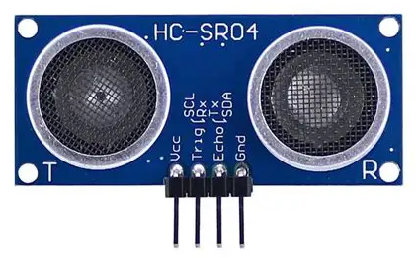
Figure 2.1 HC-SR04 Ultrasonic Sensor Module

Working principle of HC-SR04
The operation of the HC-SR04 occurs in four stages:
- Trigger Pulse Generation: The microcontroller sends a HIGH pulse of approximately 10 μs to the Trigger pin.
- Ultrasonic Transmission: The sensor emits eight ultrasonic pulses at 40 kHz.
- Echo Reception: The sound waves strike an obstacle and are reflected to the receiver.
- Distance Computation: The Echo pin remains HIGH for the duration required for the sound wave to return. The microcontroller measures this duration and computes the distance.
Table 2.1 Technical specifications of HC-SR04
Parameter | Value
Operating Voltage | 5V DC
Operating Current | 15 Ma
Operating Frequency | 40 kHz
Measuring Range | 2 cm – 400 cm
Accuracy | ±3 mm
Trigger Pulse Width | 10 μs
Measuring Angle | Approximately 15°

Microcontroller Technology
The microcontroller acts as the brain of the proposed system by processing sensor inputs and controlling system outputs.

Arduino Nano development board
The Arduino Nano is a compact microcontroller development board based on the ATmega328P microcontroller.
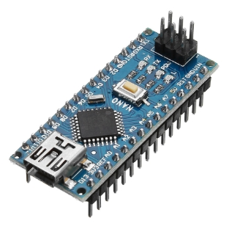
Figure 2.2 Arduino Nano Development Board
The board was selected because of its small physical size, low cost, ease of programming, large community support and its compatibility with ultrasonic sensors and LCD modules.

Technical specifications of Arduino Nano
Parameter | Specification
Microcontroller | ATmega328P
Operating Voltage | 5V
Clock Frequency | 16 MHz
Flash Memory | 32 KB
SRAM | 2 KB
EEPROM | 1 KB
Digital I/O Pins | 14
Analog Input Pins | 8
Communication Interfaces | UART, SPI, I²C

Arduino Nano pin description
Because the project comprises two physically separate units, each unit operates its own Arduino Nano with a dedicated pin assignment. Table 2.2 presents the pin allocation for Unit 1 (obstacle avoidance) and Table 2.3 presents the pin allocation for Unit 2 (parking space allocation).
Table 2.2 Arduino Nano Pin Allocation Unit 1 (Obstacle Avoidance System)
Pin | Direction | Connected To | Function
D2 | Output | HC-SR04 Trigger (Front) | 10 µs trigger pulse, front sensor
D3 | Input | HC-SR04 Echo (Front) | Echo timing, front distance
D4 | Output | HC-SR04 Trigger (Rear) | 10 µs trigger pulse, rear sensor
D5 | Input | HC-SR04 Echo (Rear) | Echo timing, rear distance
D6 | Output | HC-SR04 Trigger (Side) | 10 µs trigger pulse, side sensor
D7 | Input | HC-SR04 Echo (Side) | Echo timing, side distance
D8 | Output | Active Buzzer | Audible proximity alert
D11 | Output | Red LED | Danger zone indicator
D12 | Output | Yellow LED | Caution zone indicator
D13 | Output | Green LED | Safe zone indicator
A4 | I²C SDA | LCD SDA | I²C data to 16×2 LCD
A5 | I²C SCL | LCD SCL | I²C clock to 16×2 LCD
5V | Power | HC-SR04 VCC, LCD VCC | Regulated 5 V supply
GND | Ground | All components | Common ground reference

Table 2.3 Arduino Nano Pin Allocation Unit 2 (Parking Space Allocation System)
Pin | Direction | Connected To | Function
D2 | Output | HC-SR04 Trigger (Bay) | 10 µs trigger pulse, bay sensor
D3 | Input | HC-SR04 Echo (Bay) | Echo timing, bay distance
D8 | Output | Green LED | Slot free indicator
D9 | Output | Red LED | Slot occupied indicator
A4 | I²C SDA | LCD SDA | I²C data to 16×2 LCD
A5 | I²C SCL | LCD SCL | I²C clock to 16×2 LCD
5V | Power | HC-SR04 VCC, LCD VCC | Regulated 5 V supply
GND | Ground | All components | Common ground reference

Functions of the Arduino Nano in the proposed system
The functions of Arduino Nano include acquisition of sensor data, distance calculations, parking occupancy determination, decision-making operations, LCD control, LED indicator control and buzzer activation and deactivation. Through these functions, the microcontroller coordinates all activities within the proposed system.

Liquid Crystal Display (LCD)
A Liquid Crystal Display (LCD) is an electronic display device that uses liquid crystal materials to present information in the form of text, numbers, and symbols. LCDs are widely used in embedded systems because of their low power consumption, compact size, affordability, and ease of interfacing with microcontrollers (Mazidi et al., 2017).
The 16×2 LCD is one of the most commonly used display modules in embedded applications. It consists of two rows and sixteen columns, allowing a maximum of thirty-two characters to be displayed simultaneously. LCD modules are commonly employed in monitoring and control systems to provide users with real-time information regarding system operation and status.
In automotive and parking assistance applications, LCD modules can be used to display obstacle distances, parking slot occupancy status, warning messages, and other useful information. The integration of an LCD into the proposed system enhances user interaction by providing clear visual feedback regarding detected obstacles and available parking spaces.
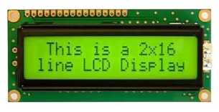
Figure 2.3 16×2 Liquid Crystal Display

I²C LCD interface
The Inter-Integrated Circuit (I²C) protocol is a serial communication standard developed by Philips Semiconductor for communication between integrated circuits using only two communication lines known as Serial Data (SDA) and Serial Clock (SCL) (Axelson, 2015).
An I²C LCD module incorporates an I²C interface adapter that significantly reduces the number of microcontroller pins required for communication. Instead of using multiple data and control pins, only the SDA and SCL lines are needed to communicate with the display.
The use of I²C communication offers several advantages, including reduced wiring complexity, efficient use of microcontroller pins, simplified circuit design, and improved scalability. In the proposed system, the I²C LCD module is connected to the Arduino Nano through pins A4 (SDA) and A5 (SCL), enabling efficient display of distance measurements and parking allocation information.
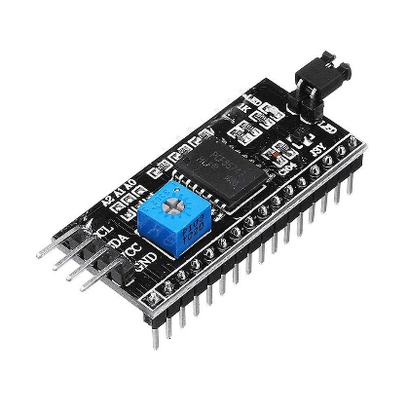
Figure 2.4 I²C LCD interface

Electronic buzzer technology
A buzzer is an electroacoustic device used to generate audible signals in electronic systems. Buzzers are commonly employed as warning and notification devices in safety systems, security systems, household appliances, industrial equipment, and automotive applications (Bolton, 2021).
Buzzers can generally be classified into two categories: active buzzers and passive buzzers. Active buzzers contain an internal oscillating circuit and generate sound when supplied with a direct current voltage. Passive buzzers require an external oscillating signal from a microcontroller or signal generator to produce sound.
In embedded safety systems, buzzers serve as immediate warning devices that attract the attention of users whenever abnormal conditions are detected. The proposed car safety system uses a buzzer to provide audible alerts whenever an obstacle is detected within a predefined safety distance. This enhances driver awareness and reduces the likelihood of collisions during vehicle manoeuvring and parking operations.
The use of audible warning systems complements visual indicators by ensuring that drivers receive alerts even when they are not actively observing the display unit.
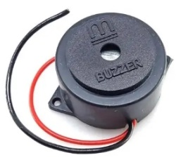
Figure 2.5: Electronic (Sound) Buzzer

Software Development Tools

Arduino Integrated Development Environment (IDE)
The Arduino Integrated Development Environment (IDE) is an open-source software platform used for writing, compiling, and uploading programs to Arduino microcontroller boards. The IDE supports programming in C and C++ languages and provides a user-friendly environment suitable for both beginners and advanced developers (Arduino, 2024).
The Arduino IDE consists of a code editor, compiler, serial monitor, and library management tools. It simplifies embedded system development by providing built-in functions for hardware control, communication protocols, and sensor interfacing.
One of the major advantages of the Arduino IDE is its extensive collection of libraries that support a wide range of sensors, displays, communication modules, and peripheral devices. These features make it an ideal development environment for rapid prototyping and implementation of embedded systems.
In the proposed project, the Arduino IDE is used to develop and upload the program responsible for sensor data acquisition, distance computation, parking slot allocation, LCD control, and buzzer activation.

Proteus design suite
Proteus Design Suite is an electronic design and simulation software used for circuit development, testing, and verification before hardware implementation. It supports schematic design, microcontroller simulation, circuit analysis, and printed circuit board (PCB) design. In this project, Proteus is used to design and simulate the complete circuit, allowing the Arduino Nano, ultrasonic sensors, LCD, and buzzer to be tested before physical construction. This helps reduce development costs, improve system reliability, and identify design errors during the design stage (Labcenter Electronics, 2023).

Conceptual Framework
The conceptual framework for the Car Safety System with Obstacle Detection and Free Parking Space Allocation is organised around two independent Input–Process–Output (IPO) units, each coordinated by a dedicated Arduino Nano microcontroller. The two units share a common theoretical foundation in the Time-of-Flight distance measurement principle but differ in their physical deployment, sensor configuration, and output logic.
Unit 1: The obstacle avoidance system receives inputs from three HC-SR04 sensors mounted at the front, rear, and lateral positions of the vehicle. The Arduino Nano polls each sensor sequentially, computes the distance to any detected object, and identifies the minimum of the three readings as the nearest obstacle distance. This value is evaluated against two thresholds 50 cm and 20 cm to classify the proximity condition as safe, caution, or danger. The outputs corresponding to each state are: a green LED and silence for safe; a yellow LED and 1 Hz intermittent buzzer for caution; and a red LED and 4 Hz continuous buzzer for danger. The 16×2 I²C LCD simultaneously displays the numeric distance and the state label on its first row, providing the driver with both quantitative and qualitative proximity information.
Unit 2: The parking space allocation system is a static installation mounted at the entrance of a parking bay. A single HC-SR04 sensor measures the distance from the sensor to any object in the bay. The Arduino Nano compares this distance against a fixed 100 cm occupancy threshold: a distance less than 100 cm indicates a vehicle is present (slot occupied); a distance greater than or equal to 100 cm indicates the slot is clear (slot free). The outputs are a red LED and the message "SLOT OCCUPIED" on the LCD for an occupied slot, and a green LED and "SLOT FREE" for a vacant slot. A 500 ms output hold prevents rapid display flickering as a vehicle slowly enters or exits the bay.
Together, the two units address the dual objectives of the project: Unit 1 operates continuously during vehicle movement, providing real-time collision-avoidance assistance to the driver; Unit 2 operates as a fixed monitoring station, providing unambiguous slot-availability information to drivers approaching the bay. The separation of the two units into distinct Arduino Nano platforms reflects their different deployment environments and allows each unit to be designed, calibrated, and tested independently.

Development of Block Diagram
Because the system comprises two physically independent units, a separate block diagram is presented for each.

Unit 1 Obstacle Avoidance System
The block diagram of Unit 1 illustrates the functional relationship between its major subsystems. The 9 V power supply feeds the Arduino Nano through its barrel jack, with the onboard AMS1117-5.0 regulator producing the regulated 5 V supply rail for all peripherals. Three HC-SR04 ultrasonic sensors positioned at the front, rear, and side of the vehicle each connect their Trigger and Echo lines to dedicated digital GPIO pins on the Arduino Nano, which issues sequential trigger pulses and times the returning echo pulses to compute proximity distances. The Arduino Nano processes the three distance values, determines the nearest obstacle, evaluates the proximity zone, and drives the output block, which comprises the 16×2 I²C LCD display (connected via the two-wire I²C bus on pins A4 and A5), the active buzzer (connected to D8 through a 220 Ω series resistor and a 1N4148 protection diode), and three LED indicators green (safe, D13), yellow (caution, D12), and red (danger, D11) each connected through a 330 Ω series resistor.
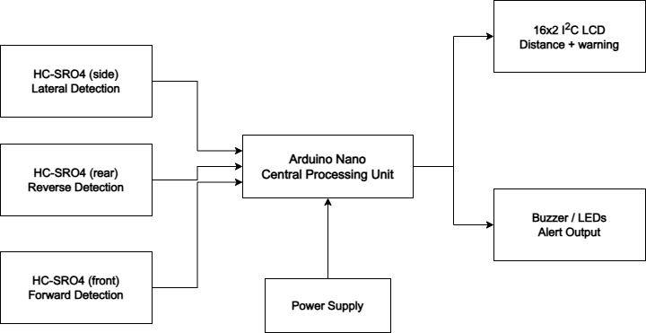
Figure 2.5 Block Diagram of Unit 1 Obstacle Avoidance System

Unit 2 Parking Space Allocation System
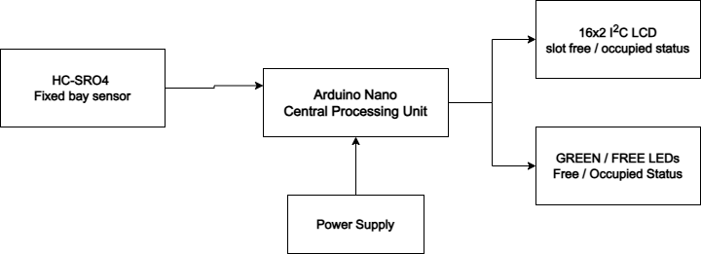
The block diagram of Unit 2 illustrates the functional relationship between its major subsystems. The 9 V power supply feeds a dedicated Arduino Nano whose onboard regulator supplies the 5 V rail. A single HC-SR04 ultrasonic sensor, mounted at a fixed height of approximately 30–50 cm at the entrance of the parking bay, connects its Trigger pin to D2 and its Echo pin to D3 of the Arduino Nano. The Arduino Nano executes the occupancy determination algorithm and drives two output subsystems: the 16×2 I²C LCD module (pins A4 and A5) displays the textual slot status, while two LED indicators green (slot free, D8) and red (slot occupied, D9) provide an immediately visible binary status indication to approaching drivers. Both LEDs are connected through 330 Ω series current-limiting resistors.
Figure 2.6 Block Diagram of Unit 2 Parking Space Allocation System

Review of Related Empirical Studies
A number of empirical studies have examined the application of ultrasonic sensing, microcontroller-based automation, and embedded obstacle detection systems in automotive and parking management contexts. Bogue (2015) conducted a comprehensive review of sensors employed in automotive applications and identified ultrasonic sensing as one of the most reliable and cost-effective approaches for short-range proximity detection in parking assistance systems. The review noted that HC-SR04-type sensors operating on the Time-of-Flight principle are widely favoured for low-cost implementations due to their sufficient accuracy, straightforward microcontroller interface, and robust performance in close-range detection scenarios findings that directly support the sensor selection adopted in this project.
Valvano (2014) provided detailed treatment of embedded system design principles applicable to real-time automotive control, establishing that microcontrollers such as the ATmega328P-based Arduino Nano are capable of managing multiple concurrent sensor polling loops within the timing constraints of practical automotive applications. Valvano's work underlines the suitability of the Arduino Nano as the processing core of a real-time safety system, confirming that its 16 MHz clock frequency and 32 KB flash memory are adequate for the sensor polling, distance computation, decision logic, and peripheral control functions required by this project.
Bolton (2021) examined the theoretical and practical aspects of ultrasonic sensing in mechatronic systems, confirming that the 40 kHz operating frequency and 2 cm to 400 cm detection range of the HC-SR04 make it suitable for both obstacle detection during vehicle manoeuvring and parking slot occupancy determination. Bolton's analysis also validated the Time-of-Flight distance formula used in this project, demonstrating that the speed of sound approximation of 343 m/s at 20 °C yields measurement errors within ±3 mm under typical indoor and sheltered outdoor conditions.
The World Health Organisation (2023) global report on road safety identified inadequate obstacle awareness during parking and low-speed manoeuvring as a significant contributor to minor vehicle collisions and property damage, particularly in densely populated urban environments. The report emphasised the value of low-cost electronic warning systems in reducing such incidents, especially in developing countries where high-end factory-installed driver assistance systems are not accessible to the majority of vehicle owners a gap that the present project directly addresses.
Collectively, these studies validate the component selections and design approach adopted in this project. However, none of the reviewed works has produced a unified, self-contained, Arduino Nano-based prototype that simultaneously performs multi-directional obstacle detection and free parking space identification with audible and visual outputs in a single low-cost system. The present project addresses this gap.

Summary of Literature Review
The reviewed literature including works by Bogue (2015), Valvano (2014), Bolton (2021), and the World Health Organisation (2023) confirms that ultrasonic sensing based on the Time-of-Flight principle provides reliable, low-cost distance measurement suitable for both obstacle detection and parking slot occupancy determination. The Arduino Nano, based on the ATmega328P microcontroller, has sufficient processing capability to manage multiple concurrent sensor channels, perform real-time distance calculations, and drive LCD and buzzer output peripherals simultaneously. The 16×2 I²C LCD module reduces wiring complexity through its two-wire serial interface, while the active buzzer provides immediate audible alerts without requiring an external oscillating signal. The reviewed literature further confirms that such systems address a genuine safety need, particularly in developing-country automotive contexts. No prior study has integrated all these components multi-channel HC-SR04 obstacle detection, parking slot monitoring, I²C LCD display, and audible warning into a single, deployable Arduino Nano prototype, and the present project addresses this gap.

CIRCUIT ANALYSIS AND DESIGN

Introduction
This chapter presents the detailed electrical analysis and component-selection rationale for both units of the car safety system. Unit 1 is the vehicle-mounted obstacle avoidance system, comprising three HC-SR04 ultrasonic sensors, an Arduino Nano, a 16×2 I²C LCD, an active buzzer, and three LED indicators. Unit 2 is the fixed-installation parking space allocation system, comprising one HC-SR04 sensor, a second Arduino Nano, a 16×2 I²C LCD, and two LED indicators. Each unit is powered by a 9 V DC supply. The chapter addresses the two fundamental engineering questions: how were the component values determined, and why were those components selected over available alternatives? Circuit diagrams, operational flowcharts, and programming details are presented for each unit in turn.

Arduino Nano Microcontroller – Central Processing Unit
Each unit uses a dedicated Arduino Nano microcontroller based on the ATmega328P 8-bit AVR core running at 16 MHz. The Arduino Nano was selected for both units on the basis of its compact footprint (45 mm × 18 mm), onboard 5 V regulation, hardware I²C support on pins A4 and A5, and comprehensive library support for the HC-SR04 and I²C LCD peripherals. The Arduino Uno was considered but rejected because its 68.6 mm × 53.4 mm footprint is unnecessarily large for a vehicle-mounted installation. The Raspberry Pi was considered for its higher processing power but rejected as over-specified for a deterministic polling loop requiring no operating system or network connectivity. The ATmega328P at 16 MHz executes the Unit 1 three-sensor polling loop, distance computations, threshold evaluations, and output updates within a total cycle time of approximately 75 ms, and the simpler Unit 2 single-sensor loop within approximately 25 ms, both of which are adequate for the response-time requirements of their respective applications.

Pin Assignment and Rationale – Unit 1
The Unit 1 pin assignments were determined by the need to assign six GPIO pins (three trigger–echo pairs) to the obstacle sensors, one PWM-capable pin to the buzzer, three GPIO pins to the LED indicators, and pins A4 and A5 to the hardware I²C bus. Table 3.1 presents the complete Unit 1 pin allocation.

Table 3.1 Arduino Nano Pin Allocation — Unit 1 (Obstacle Avoidance)
Pin | Direction | Connected To | Function | Design Note
D2 | Output | Front HC-SR04 Trigger | 10 µs trigger pulse
D3 | Input | Front HC-SR04 Echo | Echo timing
D4 | Output | Rear HC-SR04 Trigger | 10 µs trigger pulse
D5 | Input | Rear HC-SR04 Echo | Echo timing
D6 | Output | Side HC-SR04 Trigger | 10 µs trigger pulse
D7 | Input | Side HC-SR04 Echo | Echo timing
D8 | Output | Buzzer | Audible alert | 220 Ω + 1N4148
D11 | Output | Red LED | Danger indicator | 330 Ω series
D12 | Output | Yellow LED | Caution indicator | 330 Ω series
D13 | Output | Green LED | Safe indicator | 330 Ω series
A4 | I²C SDA | LCD SDA | I²C data | 4.7 kΩ on module
A5 | I²C SCL | LCD SCL | I²C clock | 4.7 kΩ on module
5V | Power | All VCC lines | 5 V supply output | Via onboard reg.
GND | Ground | All GND lines | Common reference

Pin Assignment and Rationale — Unit 2
The Unit 2 pin assignments use only two GPIO pairs for the single sensor and two GPIO pins for the LED indicators, with A4 and A5 reserved for the I²C LCD. Table 3.2 presents the complete Unit 2 pin allocation.

Table 3.2 Arduino Nano Pin Allocation — Unit 2 (Parking Space Allocation)
Pin | Direction | Connected To | Function
D2 | Output | Bay HC-SR04 Trigger | 10 µs trigger pulse
D3 | Input | Bay HC-SR04 Echo | Echo timing, bay distance
D8 | Output | Green LED | Slot free indicator — 330 Ω series
D9 | Output | Red LED | Slot occupied indicator — 330 Ω series
A4 | I²C SDA | LCD SDA | I²C data — 4.7 kΩ pull-up on module
A5 | I²C SCL | LCD SCL | I²C clock — 4.7 kΩ pull-up on module
5V | Power | HC-SR04 VCC, LCD | Regulated 5 V supply output
GND | Ground | All GND lines | Common ground reference

HC-SR04 Ultrasonic Sensor Interface and Distance Calculation
All four HC-SR04 sensors across both units are powered from the respective Arduino Nano’s regulated 5 V output pin. The Trigger and Echo pins connect directly to 5 V logic GPIO pins on the ATmega328P. The HC-SR04 produces a 5 V logic output on its Echo pin, which is within the acceptable input range of the ATmega328P (VCC + 0.5 V = 5.5 V maximum), so no level conversion is required for either unit.

Trigger Pulse Timing
The Arduino Nano initiates each distance measurement by driving the Trigger pin HIGH for exactly 10 µs, then LOW, using the digitalWrite() and delayMicroseconds() functions. The HC-SR04 responds by emitting eight 40 kHz ultrasonic bursts and holding the Echo pin HIGH for a duration proportional to the round-trip travel time of the sound wave.

Distance Calculation
The Arduino Nano measures the duration of the Echo HIGH pulse using the pulseIn() function. The distance is then calculated using the Time-of-Flight formula:
$$d = (v × t) / 2$$
Where d = distance (cm), v = speed of sound ≈ 343 m/s = 0.0343 cm/µs, t = echo pulse duration in microseconds. Substituting the speed of sound:
$$d (cm) = pulse_duration (µs) × 0.0343 / 2 = pulse_duration (µs) / 58.3$$
For example, if the Echo pin is HIGH for 1,166 µs, the measured distance is:
$$d = \frac{1,166}{58.3 }≈ 20 cm$$
In firmware, this is implemented as: distance = pulseIn(echoPin, HIGH) / 58.3. The HC-SR04 is rated for a measuring range of 2 cm to 400 cm with an accuracy of ±3 mm. Readings below 2 cm or above 400 cm are filtered out in software and treated as invalid, preventing spurious LCD updates or false buzzer activations.

Sensor Polling Sequence – Unit 1
To prevent acoustic cross-talk between the three sensors sharing the same 5 V rail, Unit 1 uses a sequential polling strategy: Sensor 1 (front) is triggered and its echo awaited before Sensor 2 (rear) is triggered, and so on. The maximum echo wait time per sensor is approximately 23.3 ms (400 cm round-trip at 0.0343 cm/µs). The total worst-case cycle time for three sequential measurements is approximately 3 × 25 ms = 75 ms including processing overhead, yielding a system response time adequate for low-speed manoeuvring at 3–10 km/h. Unit 2 triggers a single sensor every 100 ms; no cross-talk mitigation is required.

Obstacle Detection Logic and Distance Thresholds – Unit 1
The Unit 1 firmware identifies the minimum of the three sensor readings as the nearest obstacle distance and classifies it into one of three proximity zones. The thresholds were selected to provide a driver travelling at 5 km/h (1.39 m/s) at least 0.36 s of advance warning before entering the caution zone, and at least 0.14 s before entering the danger zone, consistent with the reaction-time margins discussed by Bogue (2015). Table 3.3 summarises the zones and system responses.
A five-sample rolling average is applied to each sensor reading to suppress transient noise spikes and prevent false state transitions caused by acoustic reflections from irregular surfaces.

Table 3.3 Obstacle Detection Zones and System Responses — Unit 1
Zone | Distance Range | LCD Row 1 | Buzzer | LED
Safe | > 50 cm | "SAFE XX cm" | Silent | Green ON
Caution | 20–50 cm | "CAUTION XX cm" | 1 Hz intermittent | Yellow ON
Danger | < 20 cm | "DANGER XX cm" | 4 Hz continuous | Red ON

Parking Slot Occupancy Logic — Unit 2
The Unit 2 sensor is mounted at a fixed height of approximately 30–50 cm at the entrance of the parking bay, facing the direction of incoming vehicles. The occupancy threshold is set at 100 cm: a measured distance less than 100 cm indicates a vehicle or obstruction is present; a distance greater than or equal to 100 cm indicates the slot is clear. The firmware logic is:
if (parking_distance < 100 cm) → "SLOT OCCUPIED"
if (parking_distance >= 100 cm) → "SLOT FREE"
The 100 cm threshold is stored as a configurable constant in the firmware, allowing adjustment for different bay geometries. A 500 ms output hold is applied after each state transition to prevent LCD and LED flickering as a vehicle slowly enters or exits the bay. The slot status is displayed on both rows of the LCD: row 1 shows the status label and row 2 shows the measured distance for diagnostic purposes during installation and calibration.

Buzzer Driver Circuit — Unit 1
An active buzzer rated at 5 V DC with a typical operating current of 30 mA is driven directly from Arduino Nano GPIO pin D8 through a series current-limiting resistor. A 1N4148 small-signal diode is connected in reverse-bias across the buzzer terminals to suppress the inductive back-EMF transient generated when the buzzer is de-energised, protecting the GPIO pin from reverse-voltage stress. Unit 2 does not include a buzzer; its alert function is performed solely by the LED indicators and LCD display.

Series Resistor Calculation
A target operating current of 25 mA is selected, providing adequate buzzer volume while remaining below the 40 mA GPIO absolute maximum. The required series resistance is:
$$R_series = \frac{(V_GPIO - V_buzzer_drop)}{ I_target} = \frac{(5 V - 0 V)}{0.025 A} = 200 Ω$$
The nearest standard E12-series value is 220 Ω, yielding an actual operating current of:
$$I_buzzer = 5 V / 220 Ω = 22.7 mA$$
This is within the buzzer’s rated operating range and safely below the GPIO limit. The 220 Ω value is selected for all buzzer driver circuits in this project.

LED Indicator Circuits – Both Units
Unit 1 employs three LEDs: red (D11, danger), yellow (D12, caution), and green (D13, safe). Unit 2 employs two LEDs: green (D8, slot free) and red (D9, slot occupied). All five LEDs are connected between their respective GPIO pins and ground through individual current-limiting series resistors. The LEDs have forward voltages of approximately 2.0 V (red and yellow) and 2.2 V (green), and are operated at a target current of 10 mA.

Series Resistor Calculation
For the red and yellow LEDs (V_F = 2.0 V, V_GPIO = 5 V):
$$R = \frac{(V_GPIO - V_F)}{I_LED} = \frac{(5 V - 2.0 V)}{ 0.010 A} = \frac{3.0 V}{0.010 A } = 300 Ω$$
For the green LED (V_F = 2.2 V):
$$R = (5 V - 2.2 V) / 0.010 A = 2.8 V / 0.010 A = 280 Ω$$
A standard value of 330 Ω is selected for all three indicators. At this value, the actual LED currents are:
$$I_red/yellow = (5 V - 2.0 V) / 330 Ω = 9.1 mA$$
$$I_green = (5 V - 2.2 V) / 330 Ω = 8.5 mA$$
Both values are within the 5–20 mA operating range of standard 5 mm through-hole LEDs and well below the 40 mA GPIO absolute maximum of the ATmega328P.

16×2 I²C LCD Module Interface – Both Units
Both units use a 16×2 LCD module with a PCF8574T I²C adapter, connected to the Arduino Nano on pins A4 (SDA) and A5 (SCL). The I²C bus operates at 100 kHz standard mode. The PCF8574T default I²C address is 0x27 (alternatively 0x3F for PCF8574AT variants). The LiquidCrystal_I2C library manages all display communication.

I²C Pull-up Resistor Verification
The I²C adapter module includes onboard 4.7 kΩ pull-up resistors on SDA and SCL. For 100 kHz standard-mode I²C with a 5 V supply and a bus capacitance of approximately 100 pF, the minimum allowable pull-up resistance is:
$$R_min = \frac{t_rise}{(0.8473 × C_bus)} = \frac{1,000 ns}{(0.8473 × 100 pF)} ≈ 11.8 kΩ$$
And the maximum pull-up resistance, to source 3 mA into the bus at V_OL = 0.4 V, is:
$$R_max = \frac{(VCC - V_OL)}{I_sink } = \frac{(5 V - 0.4 V)}{3 mA} ≈ 1,533 Ω$$
The onboard 4.7 kΩ resistors are within the valid range for the expected bus capacitance and operating frequency. No additional pull-up resistors are required on either unit’s main circuit board.

Power Supply Analysis – Both Units
Both units are powered from a 9 V DC source, which may be a 9 V alkaline battery or a 9 V DC wall adapter. The Arduino Nano’s onboard AMS1117-5.0 linear regulator converts the 9 V input to a regulated 5 V supply for all peripherals.

Unit 1 Current Demand
The total current demand of the system is calculated by summing the current requirements of all connected components at maximum simultaneous load:
Table 3.4 Unit 1 Power Consumption Summary
Component | Supply (V) | Typical Current | Peak Current
Arduino Nano (active) | 5 | 15 mA | 25 mA
HC-SR04 sensors ×3 | 5 | 45 mA (15 mA each) | 45 mA
16×2 I²C LCD | 5 | 20 mA | 25 mA
Active buzzer | 5 | 22.7 mA | 30 mA
LED indicators ×3 | 5 | 26 mA | 28 mA
Total | 5 | ≈129 mA | ≈153 mA

Unit 2 Current Demand
Table 3.5 Unit 2 Power Consumption Summary
Component | Supply (V) | Typical Current | Peak Current
Arduino Nano (active) | 5 | 15 mA | 25 mA
HC-SR04 sensor ×1 | 5 | 15 mA | 15 mA
16×2 I²C LCD | 5 | 20 mA | 25 mA
LED indicators ×2 | 5 | 17 mA | 18 mA
Total | 5 | ≈67 mA | ≈83 mA

Regulator Heat Dissipation
For Unit 1 at maximum load (153 mA), the AMS1117-5.0 regulator dissipates:
$$P_Unit1 = (9 V - 5 V) × 0.153 A = 4 × 0.153 = 0.612 W$$
For Unit 2 at maximum load (83 mA):
$$P_Unit2 = (9 V - 5 V) × 0.083 A = 4 × 0.083 = 0.332 W$$
Both values are within the AMS1117’s rated 1 W maximum dissipation with the standard PCB copper pad, confirming that no additional heatsinking is required. At typical loads, a 9 V alkaline battery (approximately 500 mAh) provides an estimated runtime of approximately 500 / 0.129 ≈ 3.9 hours for Unit 1 and 500 / 0.067 ≈ 7.5 hours for Unit 2 before requiring replacement.

Circuit Diagrams
Figure 3.1 presents the complete circuit diagram of Unit 1. The Arduino Nano is positioned at the centre. The three HC-SR04 sensors connect their VCC and GND lines to the 5 V and GND rails, and their Trigger and Echo lines to the GPIO pairs D2/D3, D4/D5, and D6/D7. The buzzer connects to D8 through the 220 Ω series resistor and 1N4148 diode in reverse-bias. The three LEDs connect to D11, D12, and D13 through individual 330 Ω series resistors. The I²C LCD connects to A4 and A5. All ground connections terminate on a common GND bus to prevent ground-loop noise on the echo timing lines.

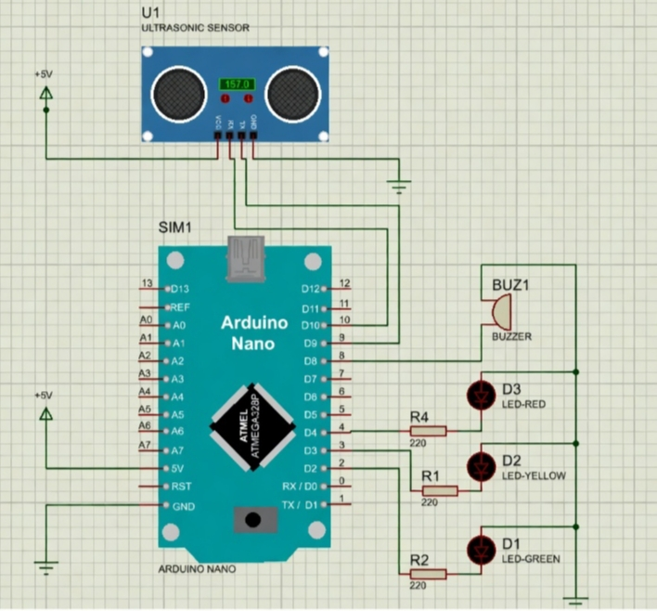
Figure 3.1 Circuit Diagram of Unit 1 — Obstacle Avoidance System
Figure 3.2 presents the complete circuit diagram of Unit 2. The single HC-SR04 connects its Trigger to D2 and Echo to D3. The green LED connects to D8 and the red LED to D9, each through a 330 Ω series resistor. The I²C LCD connects to A4 (SDA) and A5 (SCL). The 9 V supply feeds the Arduino Nano’s VIN pin. The common GND bus ties all component grounds.

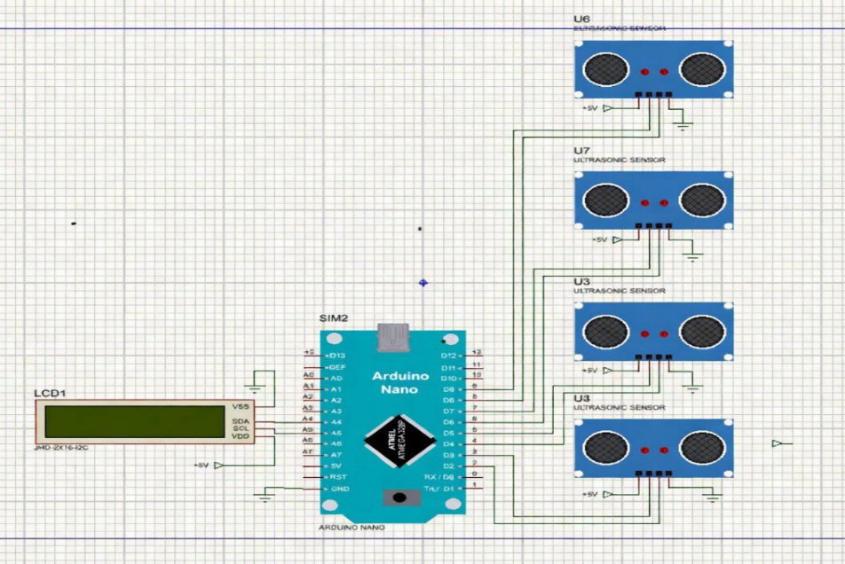
Figure 3.2 Circuit Diagram of Unit 2 — Parking Space Allocation System

System Flowcharts
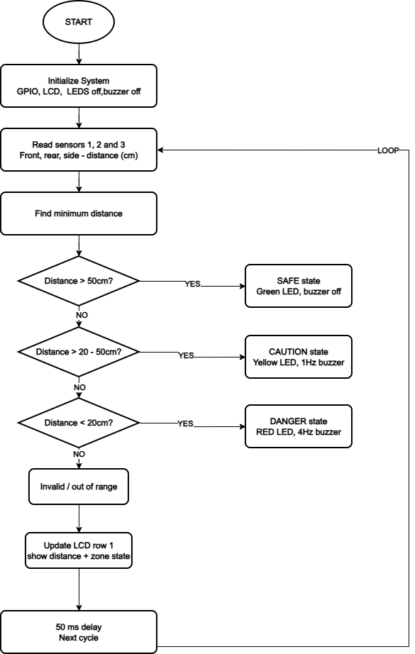
Figure 3.3 presents the operational flowchart of Unit 1. On power-up, the Arduino Nano initialises all GPIO pins, displays a splash screen on the LCD, and sets all LEDs and the buzzer to OFF. In each loop iteration, the firmware sequentially triggers and reads Sensor 1 (front), Sensor 2 (rear), and Sensor 3 (side). The minimum of the three valid readings is identified as the nearest obstacle distance and compared against the 50 cm and 20 cm thresholds. If the distance is greater than 50 cm, the system enters the SAFE state: the green LED is illuminated, the buzzer is silenced, and the LCD displays the distance with a safe label. If the distance is between 20 cm and 50 cm, the system enters the CAUTION state: the yellow LED is illuminated, the buzzer activates at 1 Hz, and the LCD displays a caution warning. If the distance is less than 20 cm, the DANGER state is entered: the red LED is illuminated, the buzzer activates at 4 Hz, and the LCD displays a danger warning. After the output state is set, the LCD is updated and a 50 ms delay is applied before the next loop iteration.
Figure 3.3 Operational Flowchart of Unit 1 — Obstacle Avoidance System
Figure 3.4 presents the operational flowchart of Unit 2. On power-up, the Arduino Nano initialises GPIO pins, displays a splash screen on the LCD, and sets both LEDs to OFF. In each loop iteration, the firmware triggers and reads the bay sensor. If the reading is invalid (out of 2–400 cm range), the firmware retries after 50 ms. For a valid reading, the distance is compared against the 100 cm occupancy threshold. If the distance is greater than or equal to 100 cm, the system enters the SLOT FREE state: the green LED is illuminated, the red LED is extinguished, and the LCD displays "SLOT FREE" on row 1 and the distance on row 2. If the distance is less than 100 cm, the system enters the SLOT OCCUPIED state: the red LED is illuminated, the green LED is extinguished, and the LCD displays "SLOT OCCUPIED" on row 1. A 500 ms hold delay is applied after each state change to suppress flicker, followed by a 100 ms polling delay before the next measurement.
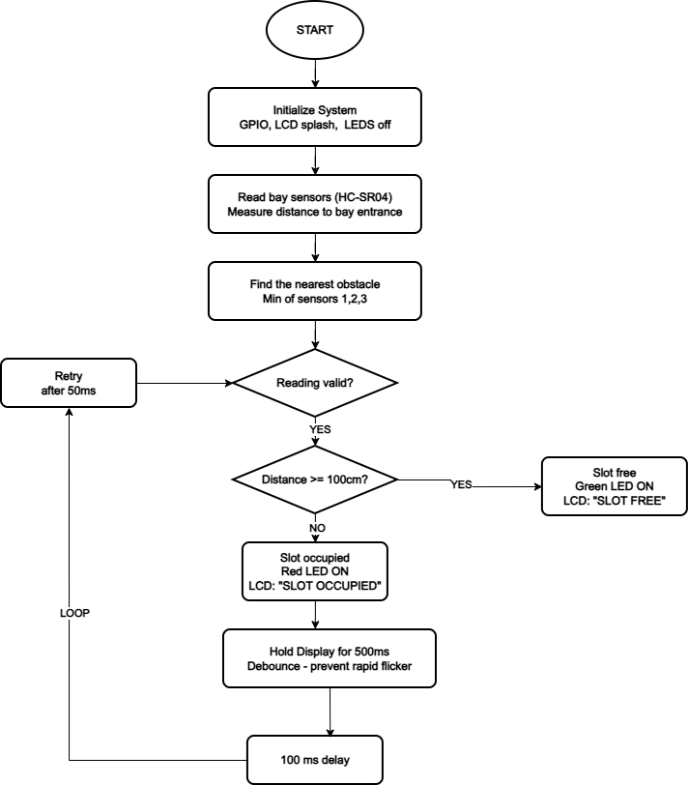
Figure 3.4 Operational Flowchart of Unit 2 — Parking Space Allocation System

Programming
The firmware for both units is written in C++ using the Arduino IDE 2.x with the Arduino AVR core for the ATmega328P. C++ was selected because it provides direct hardware access through the Arduino abstraction layer, supports the pulseIn() function required for accurate echo timing, and is the native language of the Arduino ecosystem. The Unit 1 firmware compiles to approximately 8 KB and the Unit 2 firmware to approximately 5 KB, both well within the 32 KB flash capacity of the ATmega328P.

Unit 1 Firmware Modules
The Unit 1 firmware is organised into four modules. The Sensor Acquisition Module sequentially triggers and reads all three HC-SR04 sensors using pulseIn(), computes the Time-of-Flight distance, filters out-of-range readings, and maintains a five-sample rolling average for each channel. The Proximity Decision Module evaluates the minimum of the three averaged distances against the 50 cm and 20 cm thresholds and sets a system state flag (SAFE, CAUTION, or DANGER). The Output Control Module translates the state flag into GPIO commands: it activates the correct LED, deactivates the others, and sets the buzzer PWM frequency and duty cycle. The Display Module formats the distance value and state label as strings and writes them to row 1 of the LCD using LiquidCrystal_I2C setCursor() and print() functions.

Unit 2 Firmware Modules
The Unit 2 firmware is organised into three modules. The Sensor Acquisition Module triggers the single bay sensor, reads the echo duration, computes the distance, and validates the result. The Occupancy Decision Module compares the distance against the 100 cm threshold and sets a state flag (SLOT_FREE or SLOT_OCCUPIED). The Output Control Module activates the correct LED pair and writes the status label and distance to the LCD rows, applying the 500 ms hold delay after each state transition.

Summary of Circuit Design
This chapter has presented the complete electrical analysis and component-selection rationale for both units of the car safety system. The Arduino Nano was selected for each unit on the basis of its compact size, onboard 5 V regulation, hardware I²C support, and ATmega328P library ecosystem. Unit 1 uses three HC-SR04 sensors on sequential GPIO pin pairs D2/D3, D4/D5, and D6/D7, with a worst-case three-sensor polling cycle of 75 ms. Unit 2 uses a single bay sensor on D2/D3 with a 100 ms polling interval. The Time-of-Flight formula d = pulse_duration / 58.3 was derived and validated for both units. Unit 1 defines three proximity zones — safe (> 50 cm), caution (20–50 cm), and danger (< 20 cm) — with buzzer and LED outputs scaled to zone severity; the buzzer series resistor of 220 Ω limits GPIO current to 22.7 mA. Unit 2 applies a 100 cm occupancy threshold for parking slot classification with a 500 ms state-change hold. LED series resistors of 330 Ω deliver 8.5–9.1 mA through all five indicator LEDs across both units. The I²C LCD modules’ onboard 4.7 kΩ pull-up resistors were verified to satisfy standard-mode I²C requirements for both units. The AMS1117-5.0 regulators dissipate 0.612 W (Unit 1) and 0.332 W (Unit 2) at maximum load, both within the rated 1 W limit. Chapter Four will present the physical construction

REFERENCES
Arduino. (2024). Arduino Nano. Arduino. Arduino Nano Documentation
Axelson, J. (2015). Embedded systems: Introduction to ARM® Cortex™-M microcontrollers (5th ed.). Lakeview Research.
(You cited Axelson for I²C communication. Verify the exact book used because the current citation in Chapter 2 is incomplete.)
Bolton, W. (2021). Mechatronics: Electronic control systems in mechanical and electrical engineering (7th ed.). Pearson Education.
Bogue, R. (2015). Sensors for automotive applications. Sensor Review, 35(4), 331–338. https://doi.org/10.1108/SR-01-2015-0008
Labcenter Electronics. (2023). Proteus Design Suite. Proteus Design Suite Official Website
Mazidi, M. A., Mazidi, J. G., & McKinlay, R. D. (2017). The 8051 microcontroller and embedded systems: Using assembly and C (2nd ed.). Pearson Education.
Valvano, J. W. (2014). Embedded systems: Introduction to ARM Cortex-M microcontrollers. CreateSpace Independent Publishing Platform.
World Health Organization. (2023). Global status report on road safety 2023. World Health Organization. WHO Global Status Report on Road Safety 2023

